**Preserving Language and Tradition**

**Introduction**

**The Maasai Community of Kenya**

This photographic essay will serve as a visual narrative that celebrates the resilience, diversity, and cultural richness of the Maasai people while raising awareness about the importance of language preservation and cultural continuity in indigenous communities. Experience their colorful dress, traditional jumping dance, and strong warrior-hood;

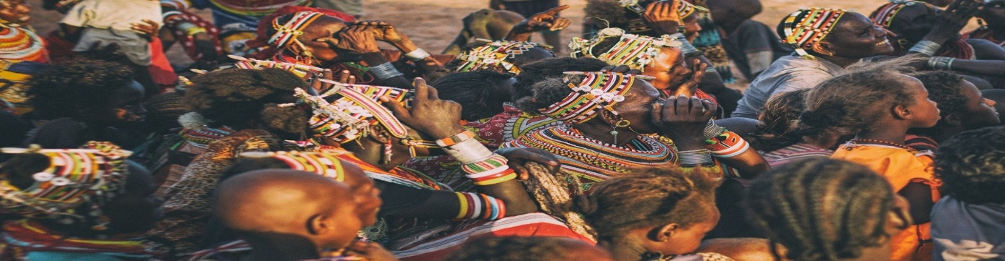

* The Maasai people are the southernmost Nilotic speakers
* Women are responsible for trade and building huts
* The Maasai were traditionally nomadic pastoralists
* Maasai people believe that cattle were given to them by God
* The Maasai refer to people without cattle as “Dorobo” which translates to “poor folk”
* Oral stories hold that the first male progenitor of the Maasai tribe was created with a herding stick in his hand.
* This African tribe drinks the blood of their cattle mixed with milk
* In the past, to become a man, young Maasai needed to kill a lion with a spear

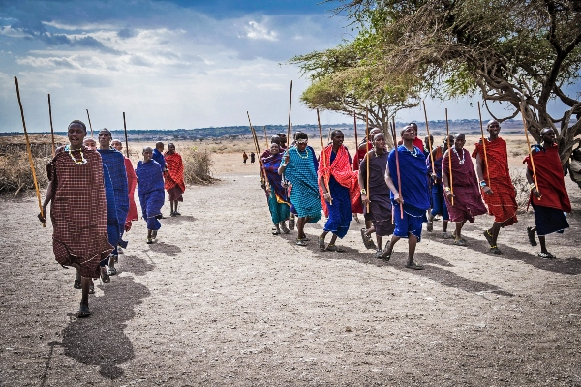

In this photographic essay, we introduce you to just a few that African culture has to offer, The Maasai.

African culture, with its unique tribes and traditions, is intriguing and diverse. Visiting these fascinating African tribe to experience their tribal customs is a sure way to make your African safari unforgettable.

**Importance of preserving Maasai indigenous language and cultural heritage.**

Chapter 1: The Maasai Way of Life.

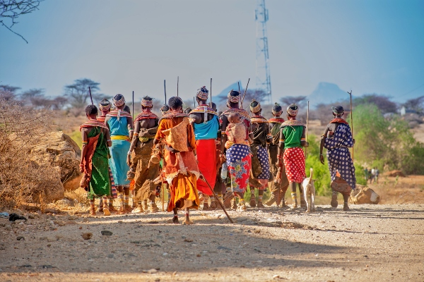

**Maasai Clothing**: Clothing varies by sex, age and place. Young men wear black for several months after their circumcision. Although, red is a favored color among the Maasai. Black, Blue, checked and striped cloth are also worn, together with multi-coloured African garments. In the 1960s the Maasai began to replace sheepskin, calf hides and animal skin for more commercial material. The cloth used to wrap around the body is the called Shúkà in the Maa language.  
The Maasai women regularly weave and bead jewellery, which plays an essential part in the ornamentation of their body. Ear piercing and the stretching of earlobes are also part of Maasai beauty, and both men and women wear metal hoops on their stretched earlobes.

Traditional Clothing of Maasai; Maasai Shuka's

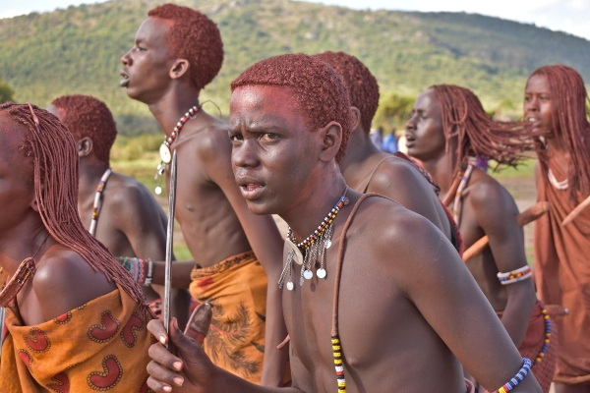

Maasai Warrior Hair Style

Maasai Hair: The maasai people, both women and men mostly shave their head to celebrate rites of passage such as circumcision and marriage. This represents the fresh start that will be made as one passes from one to another of life's chapters. It's only the Maasai warriors who are allowed to wear long hair, which they weave in thinly braided strands.  
The maasai children are named upon reaching the age of 3 "moons" and their heads are shaved clean apart apart from a tuft of hair, which resembles a cockade, from the nape of the neck to the forehead. The young boys are also shaved two days before they are circumcised. The young warriors then allow their hair to grow, and spend a great deal of time styling the hair.

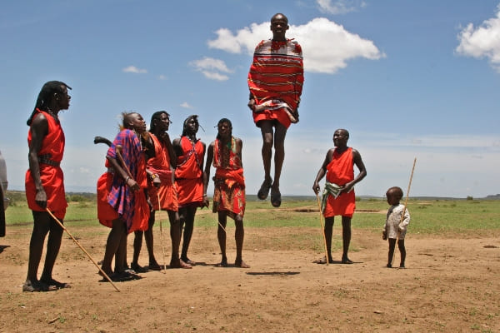

Maasai Ceremonial Dance

Maasai Music and Dance: The Maasai people don't use instruments when they are singing or dancing. All of their music is vocal, except for the large horns used for certain songs. Their music comprises of rhythms rendered by a chorus of vocalists singing harmonies, all the while the olaranyani (song leader) sings the melody. The olaranyani is usually the person who can best sing that song. When olaranyani starts singing a line or title (namba) of a song, the group responds with one unanimous call in acknowledgment. The beads that both the men and women wear also create a jingling sound themselves while the Masai jump and dance. Women recite lullabies, hum songs and sing music that praises their sons.  
The peak season for singing and dancing is during the rains, which is of course a favourable time to celebrate important passages of life such as circumcision and marriage. This mostly occur around the manyattas, and involve flirting.

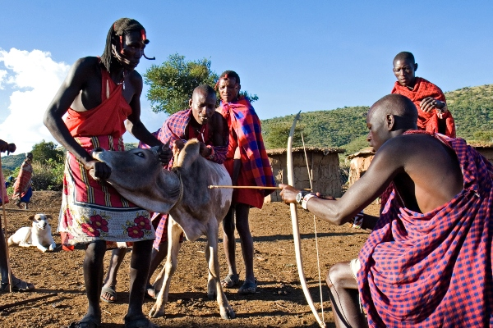

Maasai Diet

Maasai Diet: The traditional Maasai diet consists of six basic foods: meat, blood, milk, fat, honey, and tree bark. They drink both fresh and curdled milk. The fresh milk is drunk from calabash and sometimes it's mixed with fresh cattle blood. The blood is obtained by nicking the jugular vein. Mixed blood and milk is mostly used as a ritual drink and as nourishment for the sick. Bulls, oxen and lambs are slaughtered for meat on special occasions and for ceremonies. The by-products of the animals – skin and hides are used as bedding while cow dung is used for building (it is smeared on the walls). The Maasai’s entire way of life truly revolves around their cattle. More recently, the Maasai people have supplemeted their diet with farm crops such as maize meal, rice, cabbage among other food crops.

[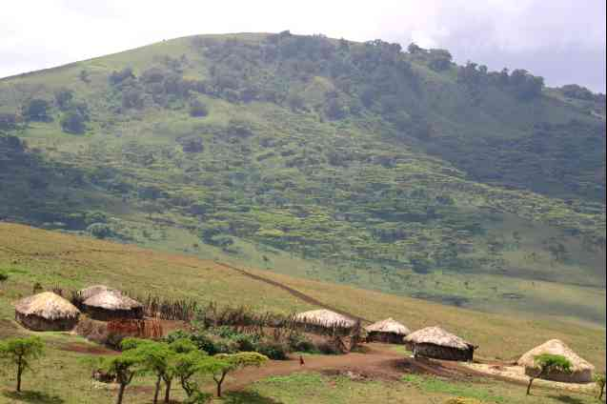](https://d2g6byanrj0o4m.cloudfront.net/images/61599/dreamstimemedium_520416.jpg) Maasai Shelter: The Maasai tribe, historically a nomadic people, have traditionally relied on readily available materials and indigenous technology to construct their unusual and interesting housing. The traditional Maasai house was designed for people on the move and thus their houses were very impermanent in nature. The houses are either circular or loaf-shaped, and are made by women. Their villages are enveloped in a circular Enkang (fence) built by the men and this protects their cattle at night from wild animals.

Maasai Traditional House

[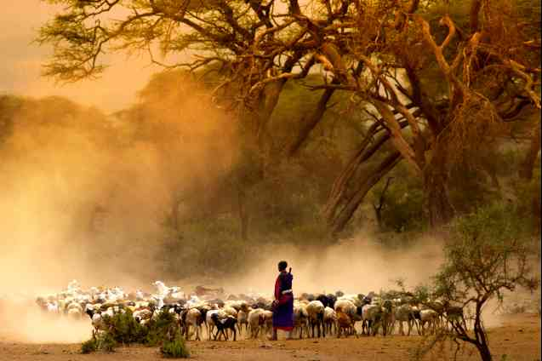](https://d2g6byanrj0o4m.cloudfront.net/images/61599/dreamstimemedium_40723201.jpg)Traditionally nomadic, Maasai are cattle and goat herders

Cattle is the core of the Maasai livelihood

[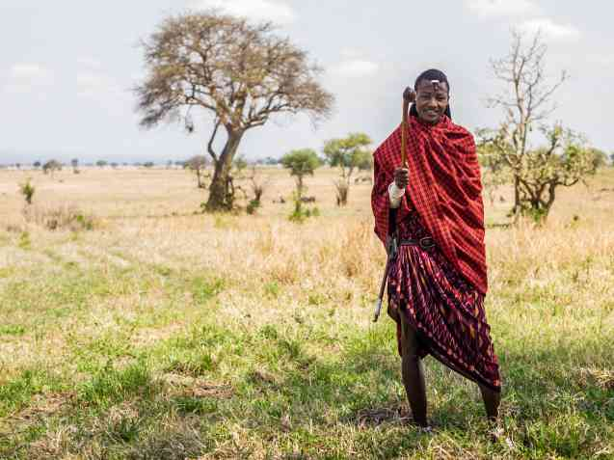](https://d2g6byanrj0o4m.cloudfront.net/images/61599/dreamstimemedium_46999811.jpg)

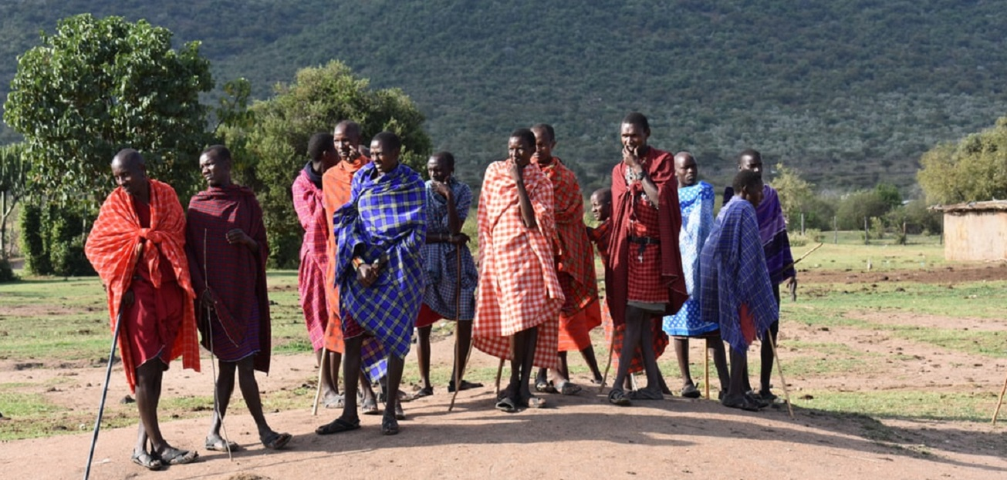 Maasai Culture: Maasai society is firmly patriarchal in nature, with elder Maasai men sometimes joined by retired elders, determining most major matters for the Maasai tribes. For Maasai people living a traditional way of life, the end of life is virtually without a formal funeral ceremony, and the dead are left out in the fields for scavengers. Burial has in the past been reserved for great chiefs only, since it is believed by the Maasai that burial is harmful to the soil.Traditional Maasai people's lifestyle concentrates on their cattle which make up the primary source of food. Amongst the Maasai the measure of a man's wealth is in terms of children and cattle. So the more the better. They believe that a man who has plenty of cattle but not many children is considered to be poor and vice versa. A Maasai myth says that God afforded them all the cattle on earth, resulting in the belief that rustling from other tribes is a matter of claiming what is rightfully theirs, a practice that has now become much less common.

Maasai Elders

[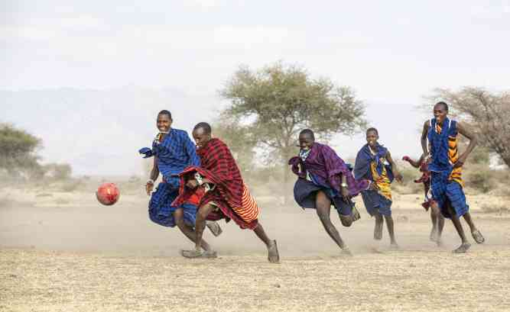](https://d2g6byanrj0o4m.cloudfront.net/images/61599/dreamstimemedium_160830961.jpg)

 Young warriors (Morans) walked in search of pasture, while protecting the cattle and the community.

Maasai Moran Warriors

[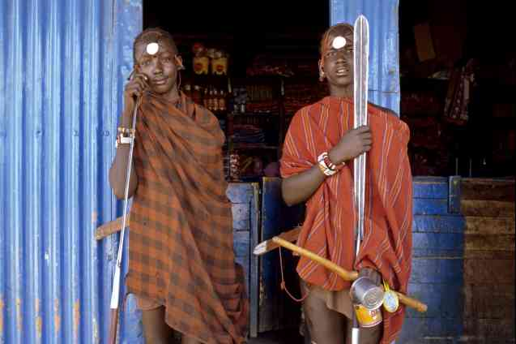](https://d2g6byanrj0o4m.cloudfront.net/images/61599/dreamstimemedium_50683892.jpg)Young Maasai warriors, armed to protect their herds

Is it Safe to Meet the Maasai Tribe in Africa?

Yes. The Maasai are renowned for their friendliness and hospitality. Kenyan safaris have thrown them a lifeline in a changing world that has allowed them to maintain their deep connection with the land. Kenyan safaris are safe and most Maasai people will welcome you into their villages to share their fascinating African culture and traditional practices.

Chapter 2: Language and Identity

[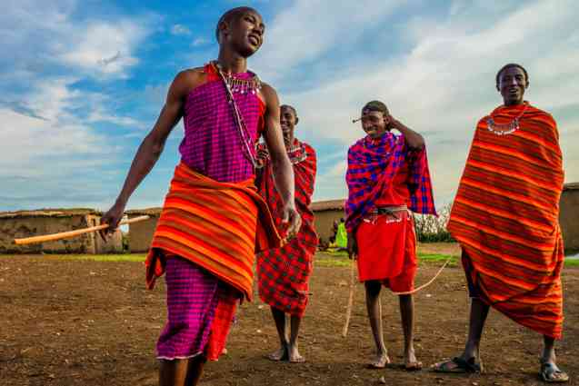](https://d2g6byanrj0o4m.cloudfront.net/images/61599/dreamstimesmall_135880334.jpg) The Maasai Tribe of Kenya

Synonymous with East Africa, the Maasai are people who speak the ‘Maa’ language. Tall and striking in appearance, their red robes stand out against the blonde grass of the African savannah. Whether standing, dancing, herding cattle, or walking amongst wild animals, images of the Maasai tribe are iconic. As nomadic pastoralists history has forced the Maasai people into an unlikely partnership with the African wilderness, tourism, and conservation.

Maasai Language

Images of Maasai elders and children engaged in conversation, storytelling, and language lessons.

Captions highlighting the importance of the Maasai language, Maa, as a symbol of cultural identity and heritage.

Chapter 3: Challenges and Resilience

Many of the cultural practices of the Maasai are still embraced today, but have been influenced by the changes in society.

Images depicting modern challenges facing the Maasai community, such as encroachment on traditional lands, globalization, and linguistic assimilation.

Captions discussing efforts by the Maasai people to preserve their language and culture, including language revitalization programs, advocacy initiatives, and cultural festivals.

Chapter 4: Intergenerational Transmission

Images showcasing the passing down of traditional knowledge and language from elders to younger generations.

Captions illustrating the role of storytelling, oral traditions, and community gatherings in maintaining cultural continuity.

Chapter 5: Celebrating Diversity

Images highlighting the linguistic and cultural diversity within the Maasai community, including different dialects, regional variations, and linguistic innovations.

Captions emphasizing the importance of embracing diversity and inclusivity in language preservation efforts.

Conclusion:

[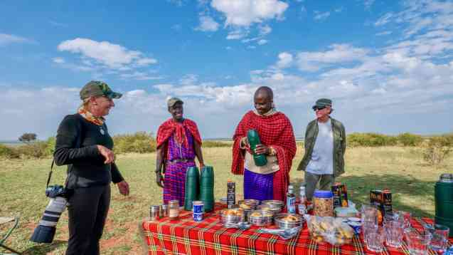](https://d2g6byanrj0o4m.cloudfront.net/images/61599/dreamstimemedium_212654776.jpg)

Why has the Maasai Tribe of Africa become so iconic?

I think that it is down to a few factors. For a start, and on a purely superficial level, their bright red and blue robes stand out against the African plains creating color combinations that are both memorable and recognizable. Second, the fact that they drink the blood of their cows is both macabre and fascinating. Thirdly, because the Maasai people have been largely displaced by the creation of national parks and protected areas, they have increased visibility. This increased visibility is due first to the cattle grazing and proximity to the parks and secondly to their involvement in tourism and conservation. Finally, the Maasai are renowned for their refusal to modernize under external pressure but have continued for decades to preserve their cultural heritage and traditions. We all secretly cheer for the small guy standing up against a bully. The Maasai tall, agile, and proud with a spear in hand ready to fight lions are just that, an iconic image of Africa standing as a bastion against inevitable change. [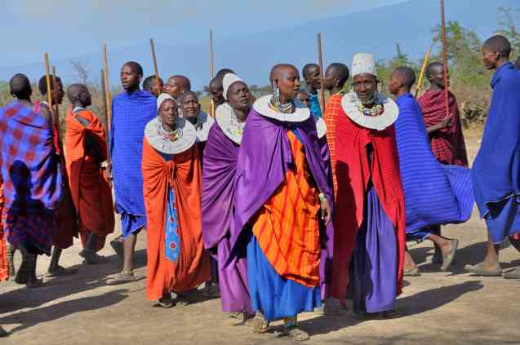](https://d2g6byanrj0o4m.cloudfront.net/images/61599/dreamstimemedium_77165110.jpg)Colourful Maasai people

The Maasai today remain a proud people with deep cultural roots and strong African traditions.

One unique and important issue in the African community is the preservation of indigenous languages and cultural heritage. Throughout Africa, there exists many languages and traditions that are at risk of being lost due to globalization, urbanization, and the dominance of colonial languages. This issue is significant because language is not only a means of communication but also a repository of cultural knowledge, history, and identity. When indigenous languages fade away, valuable cultural traditions, stories, and worldviews are also lost, eroding the cultural diversity and richness of Africa.Moreover, the loss of indigenous languages can have profound socio-economic implications, as language plays a crucial role in education, governance, and economic development. Communities that are unable to preserve their languages may face challenges in accessing quality education, participating in civic life, and preserving traditional knowledge systems.Therefore, efforts to create awareness and preserve indigenous languages are essential for preserving cultural diversity, promoting intergenerational transmission of knowledge, and fostering a sense of pride and identity among African communities. This issue requires collaborative efforts from governments, educational institutions, community organizations, and individuals to develop language policies, support language revitalization initiatives, and ensure the inclusion of indigenous languages in formal and informal settings.

One unique and important issue in the African community is the preservation of indigenous languages and cultural heritage. Throughout Africa, there exists many languages and traditions that are at risk of being lost due to globalization, urbanization, and the dominance of colonial languages. This issue is significant because language is not only a means of communication but also a repository of cultural knowledge, history, and identity. When indigenous languages fade away, valuable cultural traditions, stories, and worldviews are also lost, eroding the cultural diversity and richness of Africa.Moreover, the loss of indigenous languages can have profound socio-economic implications, as language plays a crucial role in education, governance, and economic development. Communities that are unable to preserve their languages may face challenges in accessing quality education, participating in civic life, and preserving traditional knowledge systems.Therefore, efforts to create awareness and preserve indigenous languages are essential for preserving cultural diversity, promoting intergenerational transmission of knowledge, and fostering a sense of pride and identity among African communities. This issue requires collaborative efforts from governments, educational institutions, community organizations, and individuals to develop language policies, support language revitalization initiatives, and ensure the inclusion of indigenous languages in formal and informal settings.

Maasai Tribe Facts

Maasai Religion: The Maasai people are monotheistic, and their God is named Engai or Enkai, a God who is mostly benevolent and who manifests himself in the form of different colors, according to the feelings he is experiencing. Said colors have precise meanings: black and dark blue mean that the God is well-disposed towards men; red, on the other hand, is identified with God’s irritation.

Enkai has two manifestations:  
Enkai-Narok, the Black God, good and beloved, brings grass and prosperity. He is found in thunder and rain.  
Enkai-na-Nyokie, the Red God, vengeful, brings famine and hunger. He is found in lightning and is identified with the dry season.  
The importance of cattle to the Maasai can be traced back to their religion and to Enkai. Today most of the Maasai people are christians and very few are muslims.

Beliefs, legends, and folklore

Traditionally the Maasai believed in God (referred to as Enkai), and that He created the earth with three groups of people: 1. the ‘Torrobo’, who were hunters and depended on honey and wild animals, 2. the ‘Kikuyus’, who were farmers and depended on agriculture, and 3. the Maasai, who depended on cattle for food, clothing and shelter. It is said that the Maasai originated to earth by sliding down from a rope linked to heaven. Other known legends and folklore tales include the story of Olenana, who deceived his father to obtain the blessing reserved for his older brother Senteu.

Spiritual leaders: Oloiboni and Loibon  
  
Spiritual leaders, known as Oloiboni or Loibon, were common in each Maasai family.  
  
Oloiboni had mystical as well as medicinal healing powers. They predicted the future and healed people from physical, mental and spiritual illnesses. They were in charge of the rituals, led the community in sacrifices, officiated ceremonies, and advised elders on spiritual aspects. They were also prophets, shamans and seers.  
  
Pictured here is a horn with a leather lid. It was used by a Loibon to store medicine.

The Ilkunono, a sub-group of the Maasai, were also known for being skilled blacksmiths, making cowbells and weapons.

Migration: guarding the cattle and protecting the community  
  
In the 16th century, the Maasai began migrating southwards from the lower Nile River. From the 18th century they began settling in southern Kenya and northern Tanzania. Today they reside near East African game parks.

A cowbell to keep track of the calves  
  
This iron metal cowbell (Oltuala) has a loud sound, which helped keep track of the grazing calves.

Emanyattas: ceremonial Maasai homesteads  
  
Emanyattas are ceremonial homesteads built for particular cultural ceremonies such as eunoto. These houses are made of mud, sticks and grass, and plastered with cow-dung. Traditionally, Maasai houses are built by women.

Orporor: social and political organisation

Traditionally the age-sets (orporor) system was distinctive to the Maasai community, and included many rituals and ceremonies involving birth, initiation, courtship, marriage, healing exorcisms, and death. The majority of the Maasai believed in the power of the elders in controlling political and social matters.

Eunoto ceremony: from boy to warrior  
  
Upon circumcision, boys graduated to young warriors popularly known as Morans Ilmurran. The ceremony is held every 10-15 years. It marks a new age-set.

A Maasai warrior shield  
  
Maasai warriors are known for being strong and courageous. Traditionally they protected the cattle and community with long spears and buffalo skin shields, which were decorated in red, white and black dye.

A Maasai warrior  
  
The Maasai warriors traditionally had braided hair, which is dyed with red ochre. They wore beaded necklaces, ornaments and capes (shukas) made of cowhide.

Imotonyi headdress  
  
A Maasai warrior is portrayed here wearing a Imotonyi headdress, symbolizing that he has been circumcised. The headdress is made of ostrich feathers and cow skin. He is holding a spear and shield.

A sign of bravery  
  
This Maasai warrior is likely to have killed a lion. He is wearing a headdress made of a lions mane symbolizing his bravery.

Emuratare: a girl's rite of passage  
  
Traditionally, as part of an elaborate rite of passage called 'Emuratare', young girls were circumcised around the age of 15. The ceremony initiated young Maasai girls into adulthood and then into early arranged marriages.  
  
The girl in this portrait is wearing a cowrie beads headband (isikira), which indicates that she has undergone this rite of passage.  
  
In Kenya today, female circumcision is illegal and the communities are encouraged to adopt alternative initiation rites which do not involve female genital mutilation.

Enkononkoi necklace: a symbol of the passage of rites  
  
This Enkononkoi, blue beaded necklace, is strung on a cowhide thong. It was made and worn to show that a woman had many daughters to be circumcised or married. It was also given to men by their fathers as an inheritance.

Beautiful ornaments  
  
Portrayed here is a young woman wearing traditional beaded and metallic ornaments, signifying her age and marital status.

Dancing, singing, and craftsmanship

The Maasai are known for their distinctive dress and decorative beaded jewelry. Different Maasai sub-groups can be distinguished by the color combination of their beaded jewelry. Traditional ceremonies such as the 'Eunoto', when Morans (warriors) return to their villages as mature men, offer exciting occasions for parties and enjoyment.

Maasai blanket: a woven identity  
  
The Maasai blanket or 'red shuka cloth' is perhaps one of the most recognizable symbols of Kenya and the Maasai identity. Its origin is not known, but it could have arrived with the Scottish missionaries in early 20th century, becoming increasingly popular from the 1960s onwards.  
  
The Maasai blanket is dominantly red, and made of strong thread, enabling them to endure the harsh weather.

Waist strap for traditional dancing  
  
This long leather strap was cut from cow skin and decorated with coloured beads. It was made by a skilled crafts-girl and worn around the waist by warriors as an accessory when performing traditional dances.

A blue bracelet  
  
The Maasai are known for making decorative beaded jewelry including necklaces, earrings, headbands, wrist and ankle bracelets.

Maasai warrior apron  
  
Worn by Maasai warriors, this apron was made of cow skin and decorated with metal and red, white, yellow, orange, green and blue beads.

A leather bag with beadwork  
  
To make this bag, buffalo hide was folded while still wet, and the edges were stitched. When the hide was dry, the hairs were removed using a metal scraper. The bag was used to store food and personal objects.

Celebrating Kenya's communities today

Many of the cultural practices of the Maasai are still embraced today, but have been influenced by the changes in society. The heritage and culture of the Maasai community, along with the more than 44 communities in Kenya, continues to fascinate and inspire. The National Museums of Kenya invites everyone to celebrate the intangible cultural heritage of all communities which make up this great region.